Nico DeMaria and Joshua Pollock

Lab 05 Undead Book

17 October 2016

Lab Section 1

**Problem Statement:**

This lab is asking the user to create 4 functions named: display function, update function, like function, and unlike function. After creating these three functions the user is given 37 lines of code for a main function to execute into these 4 functions.

The 4 functions that are created take in and return different values or variables. The update function takes in book, status, audience, and user id. The update function then returns a unique ID for the post by combining both the user id and the timestamp together. The like function takes in book, id, and userid. This function returns nothing. The unlike function also takes in book, id, and userid. This function also returns nothing. The display function takes in book and id. The display function returns nothing.

The update function and the display function have two required formatted outputs. The display output

looks like:

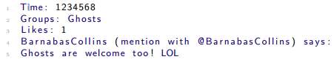

The update function looks like:



**Planning:**

We started off by creating the functions, as well as inputting the values for said functions. Then, we started writing some comments to clarify what the function was going to define. For example, for the display function, we had: # displays information on a given format.

**Implementation and Testing:**

We put together functions that we thought would work. After testing them, we then proceeded to correct them as the output was not what was desired.

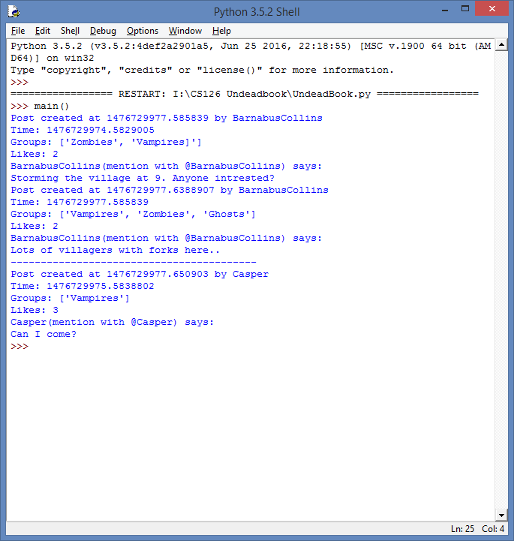

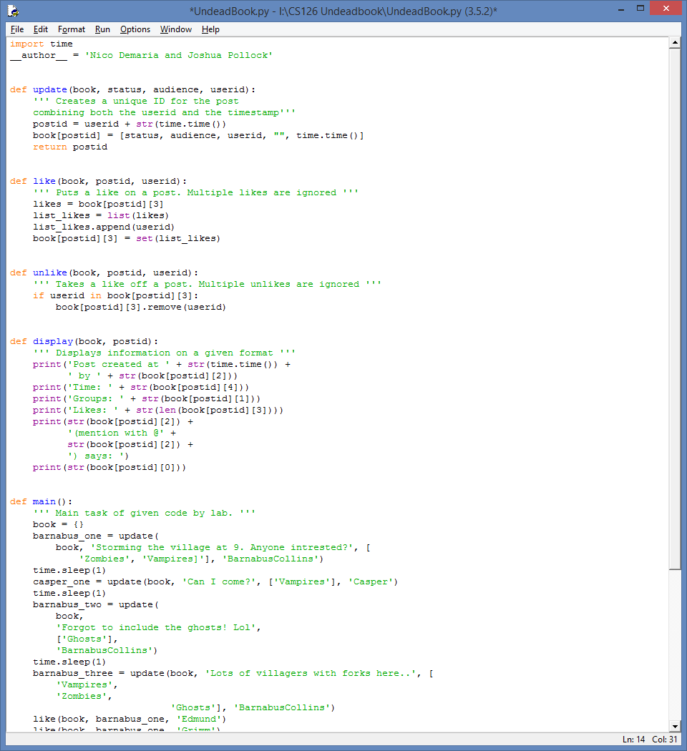

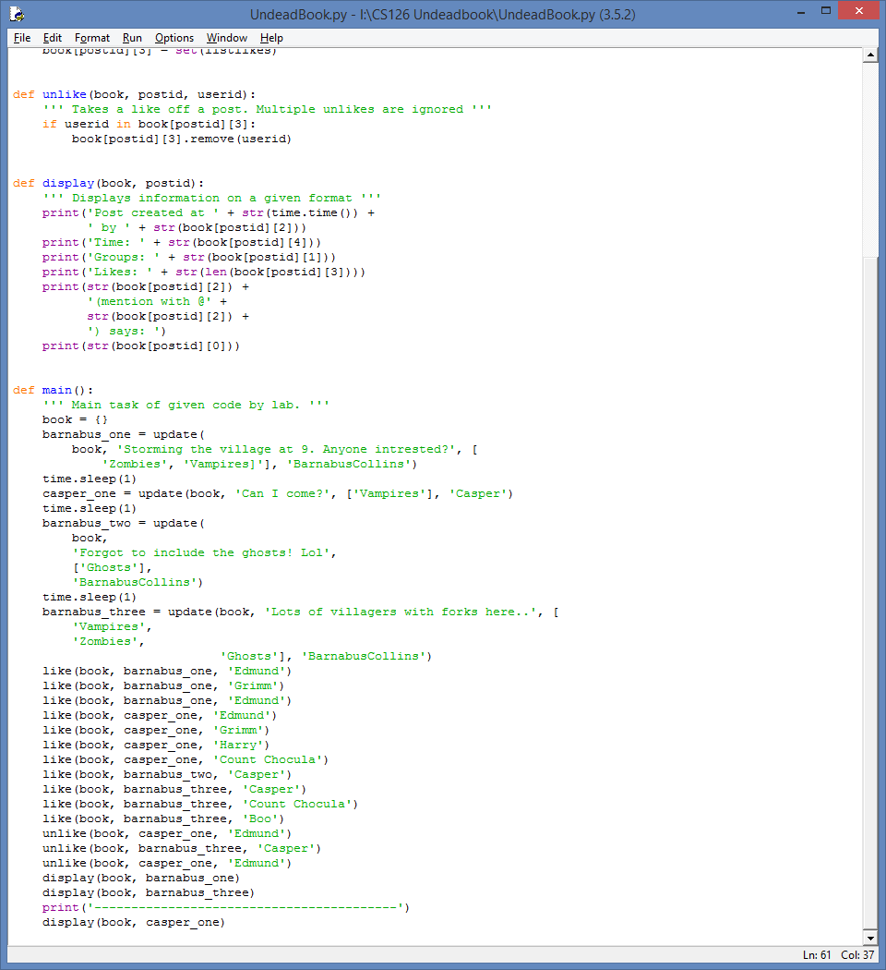

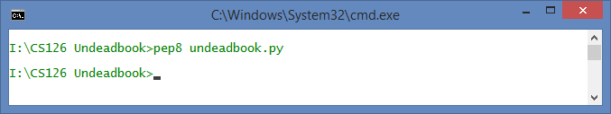

**Reflection and Refactoring:**

Overall, this lab was quite difficult. The extra week was much needed, but this proved the hardest of the labs so far. In terms of difficulty, the display function was the hardest because we had to create multiple print statements with the string of the book and postid. We could have changed the input code for us to have a different result. We could’ve also reduced or combined some of the lines of code.